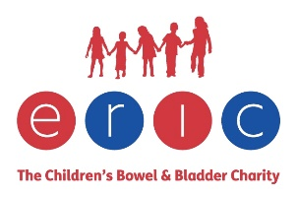

Clinic address

DATE
GP name
Name and address of surgery

Dear Doctor _____________,
Re: CHILD’S NAME DATE OF BIRTH
ADDRESS
[Child’s name] was recently seen [at home/at school/in clinic]. I have reviewed [his/her] constipation management. Despite optimal use of laxatives and diligent adherence to a regular, effective toileting programme [child’s name’s] bowel emptying problems persist.

I have explained that a range of rectal interventions exists, and that ideally the child commences a simple intervention, advancing through the more complex options as required until the optimum treatment is identified. The aim is for [child’s name] to evacuate [his/her] bowel effectively and regularly and to prevent faecal soiling.

The intervention is commenced on a daily basis, at a similar time every day. The escalating schedule is as follows:
- LecicarbonC or Bisacodyl Suppository, or Sodium Citrate Micro-Enema
- Mini rectal washout such as Qufora Mini or Aquaflush Compact
- Simple rectal washout such as Aquaflush Actif or Qufora Cone System or Dansac
- More complex bowel washout such as Peristeen or Navina or Qufora Balloon System or IryPump

The subsequent options would be surgical, either an incontinent or a continent stoma.
Prescribing information can be accessed via the ERIC website www.eric.org.uk – look for Links to Bowel Equipment Product Information.

I have explained the range of options to [child’s name] and I have given the family the ERIC leaflet ERIC’s Guide for Children living with Complex Bladder and Bowel Problems. I have suggested that the parents make an appointment to see you to discuss a prescription; the product they would like to try first is ____________________________________.

I will provide the family with teaching and support in using the products and monitor [child’s name’s] progress.

Please let me know if you require any further information. You can contact me on___________ / at _________________.

Many thanks.
Yours sincerely,

Health professional’s name
Health professional’s designation

