LINKS TO BOWEL EQUIPMENT PRODUCTS

AQUAFLUSH
Aquaflush Compact http://aquaflushmedical.com/irrigation-products/aquaflush-compact/
Aquaflush Compact Plus http://aquaflushmedical.com/irrigation-products/aquaflush-compact-plus/
Aquaflush Actif http://aquaflushmedical.com/irrigation-products/aquaflush-actif/
__________________________________________________________________________________
DANSAC
Dansac http://www.dansac.co.uk/en-gb/products/Ostomy-Care-Products/Accessories/Irrigation/Irrigation-Set

N.B. Can be used for rectal irrigation using 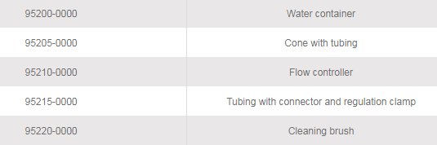
__________________________________________________________________________________
IRYPUMP
Irypump https://www.bbraun.co.uk/en/products-and-therapies/ostomy/pioneer-in-colostomy-irrigation.html#

__________________________________________________________________________________
NAVINA
Navina https://www.wellspect.com/products/bowel-products/navina-for-children

__________________________________________________________________________________
PERISTEEN
Peristeen https://www.coloplast.co.uk/peristeen-anal-irrigation-system-en-gb.aspx?utm_source=Charter&utm_campaign=Peristeen&utm_medium=Link&utm_content=CharterPeristeenPage

__________________________________________________________________________________
QUFORA
Qufora Mini https://www.macgregorhealthcare.com/qufora-irrisedo-mini/
Qufora Cone System https://www.macgregorhealthcare.com/qufora-irrisedo-cone/
Qufora Balloon System https://www.macgregorhealthcare.com/qufora-irrisedo-balloon/
Qufora Irrisedo Klick https://www.macgregorhealthcare.com/qufora-irrisedo-klick/

Links correct as of March 2020

